Internet para Todos: The UPM challenge

**Problem**

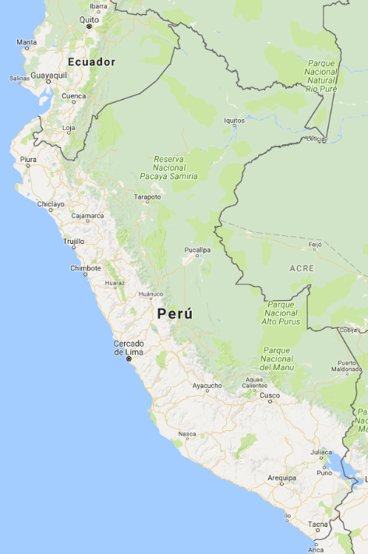

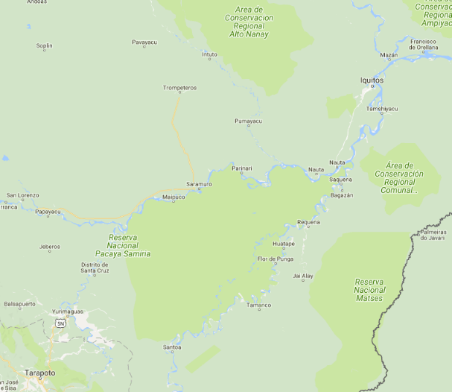

Welcome to Peru!! You have been selected as a data scientist to help a telco’s planning team connect the jungle area of Peru.

A few cities in the Amazon area, like Iquitos and Mazán remain unconnected because of their isolation. This is a huge opportunity since more than 1.5M people live in this area!

Years ago, the government deployed a bunch of towers in the jungle that are currently providing 2G service with satellite transport. This is an old technology that cannot be used to provide 4G. However, the planning team is wondering if they could leverage this infrastructure to take 4G to all this area. They do not know how to do this, though…that’s why you’re here! They want to know if there is a feasible path with microwave hops using the existing infrastructure. This would allow to take connectivity to the Amazon!

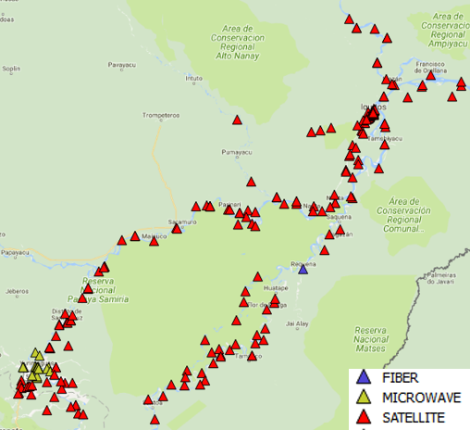

The planning team has given you the following items:

* A data set with all the towers in the area
* A modified version of this data set that tells you which towers are close enough to one another to connect them with microwave backhaul. We do not know if there is line of sight between them though
* A function that theoretically calculates line of sight between two points given the tower height at each end

**Step 1: Check that the line-of-sight function works properly**

The planning team got that function from some geeks in the innovation department. They haven’t really tested it.

They want to check if there is any chance that the fiber PoP in Requena (7465) can be used to take connectivity to Iquitos. They are not sure if there is line of sight from this tower to any other. Help them!

**Hint**: use the function provided (check_los) to determine if there is line of sight. Use its outputs to run a quick check on Excel.

**Step 2: Help the planning team to use it better**

Now that you have checked how amazing the function is, you are asked to use it to better analyze how to take connectivity to the Amazon.

The planning director tells you ‘It would be cool if we could know if there is line of sight from any tower to any other tower within a 40-km radius’.

**Hint**: complete the code provided

**Step 3: Use graph theory to help the planning team**

You successfully completed the task. However, the planning team is uncertain on how to use this new information. They really need to take connectivity You automatically respond with your typical ‘HOLD MY BEER’ sentence and take on the challenge.

You are a graph theory expert and you know that with the information you have created, it will be quite straightforward to come up with the optimal microwave paths to take connectivity from Yurimaguas (tower 6995) to Iquitos (7766), Mazán (371) and Huatape (7252).

**Hint**: Complete the code using the ‘single_source_dijkstra_path’ function from NetworkX. Explore its structure for a while and decide how to use it.

**Step 4: Budget constraints**

Unfortunately, after delivering your awesome solution, the response from the planning team is that it would require too many microwave hops. They say that if only they could use the fiber PoP in Requena (7465), everything would be easier. They only have money for 10-hop chains. Help them out!! ¿Would it be possible to connect Iquitos and Mazán with only 10-hop chains?

**Hint 1**: check what additional tower height would be needed in Requena.

**Hint 2**: add the necessary edges to the graph so that the node is considered

**Hint 3**: use the ‘cutoff’ parameter in the ‘single_source_dijkstra_path’ function

**Step 5: Optimal solution**

Well now the planning director is really impressed with your work. He wants to see what is the optimal way to connect the following cities coming from Requena (7465): Iquitos (7766), Mazán (371), Francisco de Orellana (7904) and Soromuro (76111).

As a graph theory expert, you realize this is a more complex problem. Now you can’t use the same functions since you need to design a full network, not just one path. You remember that this is a problem called ‘Minimum Spanning Tree’. Specifically, this problem is solved with a ‘Steiner Tree’. Good old Steiner!! You find a function that implements this algorithm. Use it to finish your project!!

**Hint**: Use the function steiner_tree to create the optimal network